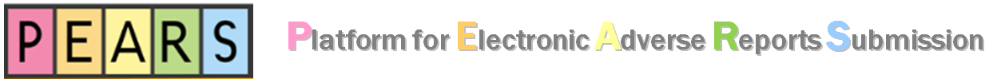
Personal Information Collection Statement
By submitting this form, you (i) express your interest in using the Platform for Electronic Adverse Reports Submission (“PEARS”) developed by HKU-CTC; (ii) agree HKU-CTC to keep, process and use your information for the purposes relating to the account set up and the use of PEARS; and (iii) agree HKU-CTC to contact you for follow up relating to PEARS. Your information provided in this form will be protected under the Personal Data (Privacy) Ordinance (“Ordinance”). Your information will be kept on a confidential basis by HKU-CTC, will be used only for the aforesaid purposes, and will not be disclosed to any third party without your prior consent. You have the right to request access to and/or correction of your personal data via the PEARS/PEARS Administrator. If you have any question about your rights under the Ordinance, you may contact the Office of the Privacy Commissioner for Personal Data of Hong Kong.

Section A. User Details
Applicant: | Name: |  | Title:
Applicant: | Email: |  | Tel:
Applicant: | Organization:
Account Type: | ☐ Corporate  ☐ Principal Investigator  ☐ PEARS Administrator  Remarks: This form is not applicable to Corporate Sub-account user. Sub-account should be created by your company’s Corporate Account holder.
Sign & Date:
Section B. Creation
User Name: | (Please provide your preferred login name)
Password: | An automatic email from PEARS Administrator (Re: Your PEARS User Account) will be sent to the user indicating the user name and password. Please change your password at initial login.
Section C. Inactivation
User Name:
Effective Date:
Reason: | ☐ The user has left the organization  ☐ Others:
Section D. CTC’s Confirmation
Received by:
Date Received:
Confirmed by QA:
Section E. Remarks
- Please return this form by email to pears@hku.hk. An automatic email from PEARS Administrator will be sent to user’s email address indicating the user name and initial password. Users are advised to change their password during initial login.
- Corporate Account user shall be responsible for managing its sub-accounts.
- Guideline for password management: (i) minimum password length: 8 characters; (ii) password expiry: 180 days; (iii) history requirement: 1; and (iv) maximum login attempts: 6.
- For inquiries, please contact our PEARS Administrator (Email: pears@hku.hk)

